
65

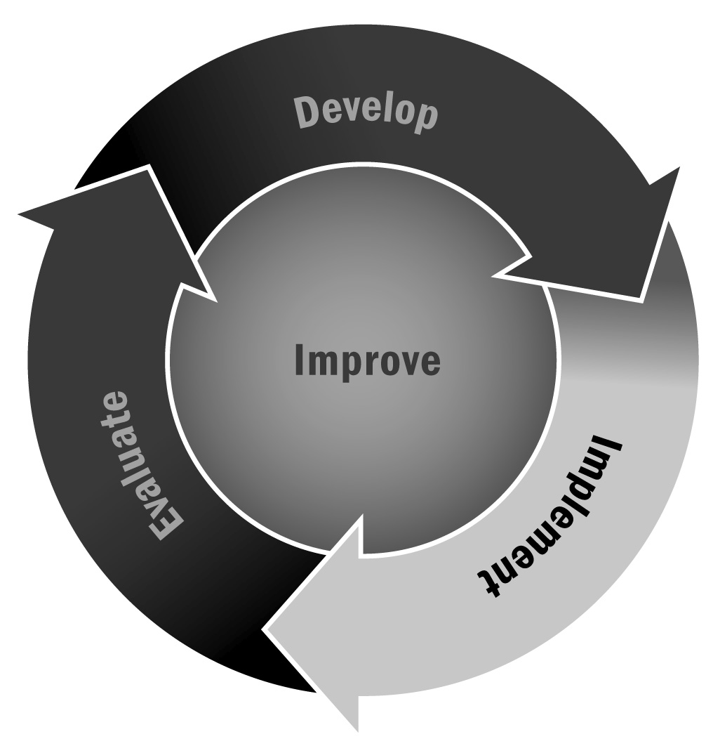
Decision Wheel
In Chapter 4, you learned that it is important for youth to learn conflict resolution skills. Having young people practice making decisions can help them prepare for situations when they have to make real-life decisions.
Directions
- Define the problem, issue, or situation. Youth should think about the
choice or problem, ask others to help them identify the problem, and look
for information to help them understand the problem.
- Identify alternatives, choices, or options. Youth should list or brainstorm all of the possible ways to solve the problem or choices available to them. This step helps them to think before making a choice and identify more than one way to deal with the problem.
- Identify consequences and risks for each choice. Think about the advantages or positive aspects of each possible choice. Then identify the disadvantages or risks involved with making each choice. Encourage youth to think about their family and personal values and how each decision may affect other people.
- Decide on one choice. What is the best alternative? Encourage youth to think about all the information they gathered about each choice and how their decision will affect them and others. Choices may also be based on knowledge, values, religious beliefs, and present and future goals.
- Evaluate the decision. Using the steps necessary for sound decision-making will not guarantee that all of the decisions youth make will be the right ones. After they make an important decision, encourage youth to think about the consequences and use this knowledge to change the decision the next time or be assured that the right decision was made.
Materials Needed
- Flip-chart paper | - Blank decision page to develop own decision situations
- Marker | - Scissors
- Yellow sticky notes | - Heavy (60-pound) paper
- Copy of Decision Wheel | - Age-appropriate decision wheel page (elementary, middle, or high school)
- Paper fasteners to assemble Decision Wheel

Leading the Activity
- Make the Decision Wheel:
- Copy (on heavy paper) enough of the Decision Wheel handouts (A and B) (on the following pages) for each youth in your group.
- Cut out the wheel with the steps to sound decision-making (wheel A) printed on the front. Cut the blank slice of the wheel out.
- Cut out the wheel with the decision situations (wheel B). Put the paper fastener through the center of the wheel to connect the two parts of the wheel.
- Draw a large Decision Wheel on a flip chart or chalkboard, and review with youth. Explain that the Decision Wheel is designed to give them practice using the skills needed for sound decision-making.
- Write the first situation from the wheel at the top of the flip-chart paper.
- Pair up youth to discuss the situation. Youth should follow the steps around the wheel to discuss the decision.
- Ask each pair to write one solution to the problem or situation per sticky note. Ask them to think about all of the possible options.
- Ask each pair to also write the consequences of each solution on a separate sticky note.
- Bring the group back together and share the options and the consequences. Put the sticky notes for the choices in the “Identify Alternatives or Choices” slice of the Decision Wheel.
- Put the consequence sticky notes in the “Identify Risks and Consequences” slice of the Decision Wheel.
- When all of the options and consequences are posted, discuss with the group why they would not choose an option because they don’t like the consequences. Remove one option at a time until there is only one option left. That is the choice the group made. Remind youth that this may not be the choice that each individual would have made.
Process What the Group Learned
- Was it more difficult to think of options with positive or negative consequences?
- Why is it important to think of consequences when making a decision?
- How can collecting information about a situation help make decision-making easier?
- Describe a situation where one of your options had both negative and positive consequences.
- The next time you make a decision, what will you do differently?
The Decision Wheel handouts (see the following pages) were adapted from Hoy, P. E., Perkins, D. F., Webster, P. V., Christner, B. J., & Mock, L. (2005). After-school programs behavioral issues toolkit. University Park, PA: Department of Agricultural and Extension Education, The Pennsylvania State University. Reprinted and adapted with permission.

Decision Wheel Handouts

