Multi-Tiered Systems of Support (MTSS) Implementation
Participant Workbook
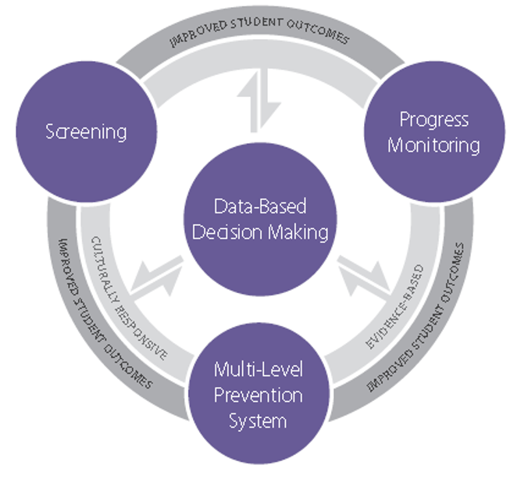

Handout 1.1: Activator Activity

 | What I Know | What I Want to Know | What I Want to Learn | Questions I Still Have
Multi-Tiered
Systems of Support
(MTSS)

Handout 1.2: Clarifying MTSS Misconceptions

What MTSS is | What MTSS is not
A prevention framework for school improvement made up of core components and features | A program or curriculum
For all students, including those students in need of enrichment | Just for struggling students or students with disabilities
Flexible for schools and districts to customize to meet their unique  circumstances | A one-size-fits-all prescriptive model
Collaborative and incorporates a team-based approach of representative stakeholders | The responsibility of one teacher or one specialist
Data driven, using multiple valid and reliable data sources | Based on assumptions or unreliable data
A framework that can be used to assist with special education decisions | Pre-referral process for special education

Handout 1.3: Activator Activity
Directions: Generate three to five practices you believe are the most important teaching practices all classroom teachers need to know, and write them in the first column. Leave the second column empty. We will revisit this activity at the end of the module.

What I believe are the most important  practices teachers need to know  to implement core instruction. | What research indicates are the most  important practices teachers need to know  to implement core instruction.
1.

2.

3.

4.

5.

Handout 1.4: High-Leverage Practice (HLP)
Expert Note-Taking Guide
Directions:
- Get into groups of 4 to 5 participants.
- Identify one of the HLPs from #7 through #22.
- Provide individual team members 5–7 minutes to review their assigned practices and highlight key points.
- Have individual team members briefly describe their assigned practices with the group (~1 minute per practice).
- Discuss implementation considerations.
A link to the high-leverage practices can be found here: https://highleveragepractices.org

Key Points | Implementation Considerations

Handout 1.5: Tools for Identifying Evidence-Based Interventions

Several online tools are available to assist educators in identifying evidence-based strategies and published interventions. This handout describes three of these resources.

What Works Clearinghouse (WWC)
- Topics: Literacy, Mathematics, Science, Student Behavior, Youth with Disabilities, College and Career, Dropout, Early Childhood, Education Technology, English Language Learners
- Resources: Intervention Research Reports, Practice Guides, Videos of Effective Math Practices, Reviewed Research Studies
- Search Features: Search by topic and subcomponents, grade (preK to 16), effectiveness, delivery method (whole class, small group, 1:1), program type (curriculum, intervention, practice), race, gender
- Results: Improvement Index (expected change in percentile rank), effectiveness rating (e.g., positive, potentially positive, mixed), effect size (overall and by subcomponents found at end of Intervention Report)
- Funding Source: Institute of Education Sciences, U.S. Department of Education
- Website: http://ies.ed.gov/ncee/wwc/

National Center for Intensive Interventions (NCII) Tools Charts
- Topics: Academic (Mathematics, Reading, Writing) and Behavior
- Resources: Behavior and Academic Interventions Tools Charts, Glossary of Terms, User Guide, Audio Tour, Progress Monitoring Tools Charts, Webinars, Sample Lessons and Activities, Newsletters
- Search Features: Search by elementary or middle/high school, subject/behavior, effect size, study, intervention title, study quality
- Results: Quality of research study (e.g., fidelity of implementation, participants, design), effect size (targeted and broad measures), intervention implementation information (group size, duration, delivery method)
- Funding Source: Office of Special Education Programs, U.S. Department of Education
- Website: www.intensiveintervention.org

Best Evidence Encyclopedia
- Topics: Mathematics, Reading, Science, School Reform, Early Childhood, Technology, English Language Learners
- Resources: Magazine, Articles, Program Reviews, Newsletters, Full Reports, Educator Summaries
- Search Features: Search by topic, elementary or middle/high school, top-rated programs,
- Results: Rating of Evidence of Effectiveness (strong, moderate, limited or insufficient evidence), type of program, description
- Funding Source: Johns Hopkins University School of Education’s Center for Data-Driven Reform in Education (CDDRE) under funding from the Institute of Education Sciences, U.S. Department of Education.
- Website: www.bestevidence.org

Handout 1.6: Data-Based Individualization Process
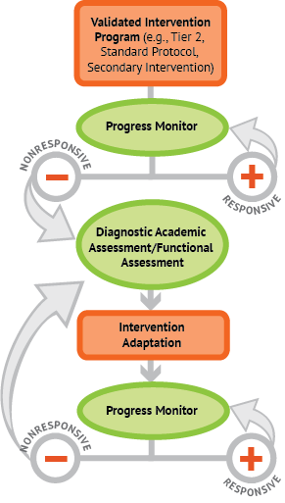

Source: National Center on Intensive Intervention (NCII), http://www.intensiveintervention.org/

MTSS Presentation Glossary

Core curriculum. The core curriculum includes the materials and instructional standards required of all students in the general education setting. Core curricula often are instituted at the elementary and secondary levels by local school boards, departments of education, or other administrative agencies charged with overseeing education.
Data-based decision making. Data-based decision making is the ongoing process of analyzing and evaluating student data to inform educational decisions, including but not limited to approaches to instruction, intervention, allocation of resources, development of policy, movement within a multi-level system, and disability identification.
Evidence-based intervention. An evidence-based intervention is an intervention for which data from scientific, rigorous research studies have demonstrated (or empirically validated) the efficacy of the intervention. Applying findings from experimental studies, single-case studies, or strong quasi-experimental studies, an evidence-based intervention improves student learning beyond what is expected without that intervention.
Fidelity of implementation. Fidelity of implementation refers to the accurate and consistent delivery of instruction or assessment in the manner in which it was designed or prescribed according to research findings and/or developers’ specifications. Five common aspects of fidelity are adherence, exposure, program differentiation, student responsiveness, and quality of delivery.
Individualized Education Program (IEP). An IEP is a legal document that describes the plan for delivering specially designed instruction, related services, and accommodations to meet the educational needs of a student with a disability.
Individuals with Disabilities Education Act (IDEA). IDEA was originally passed in 1975 as the Education for All Handicapped Children Act, with the latest reauthorization in 2004. It is the federal special education law that guarantees a free, appropriate, public education in the least restrictive environment for students with disabilities from birth through age 21. IDEA 2004 allows response to intervention to be used as a basis for decision making when determining whether a student is eligible for special education services as a student with a learning disability.
Multi-Tiered Systems of Support (MTSS). MTSS is a prevention framework that organizes building-level resources to address each individual student’s academic and/or behavioral needs within intervention tiers that vary in intensity. MTSS allows for the early identification of learning and behavioral challenges and timely intervention for students who are at risk for poor learning outcomes. It also may be called a multi-level prevention system. The increasingly intense tiers (e.g., Tier 1, Tier 2, Tier 3), sometimes referred to as levels of prevention (i.e., primary, secondary, intensive prevention levels), represent a continuum of supports. Response to intervention (RTI) and positive behavioral interventions and supports (PBIS) are examples of MTSS.
Positive Behavioral Interventions and Supports (PBIS). PBIS is a tiered behavior support framework for enhancing the adoption and implementation of a continuum of evidence-based interventions to achieve behaviorally important outcomes for all students. PBIS provides a decision-making framework that guides the selection, integration, and implementation of preventive and instructive behavioral practices. For additional information, view the National Technical Assistance Center on Positive Behavioral Interventions and Supports website (https://www.pbis.org/).
Problem-solving approach. Within an MTSS or PBIS model, a problem‐solving approach is used to tailor an intervention for an individual student. A problem-solving approach typically has four stages: problem identification, problem analysis, plan implementation, and plan evaluation.
Progress monitoring. Progress monitoring is used to assess a student’s performance, to quantify his or her rate of improvement or responsiveness to intervention, to adjust the student’s instructional program to make it more effective and suited to the student’s needs, and to evaluate the effectiveness of the intervention. For additional information, view the National Center on Intensive Intervention’s Academic Progress Monitoring and Behavioral Progress Monitoring Tools Charts (http://www.intensiveintervention.org/resources/tools-charts).
Screening. Screening is conducted to identify students who may be at risk for poor learning outcomes so that early intervention can occur. Screening assessments typically are brief and usually are administered with all students at a grade level. Some schools use a gated screening system, in which universal screening is followed by additional testing or short-term progress monitoring to confirm a student’s risk status before intervention occurs.
Tier 1. Tier 1 also may be referred to as the core curriculum or primary prevention level. The primary prevention level is the first level in a multi-level prevention system. It consists of high-quality core curriculum and research-based instructional practices that meet the needs of most students
Tier 2. Tier 2 also may be referred to as the targeted intervention or secondary prevention level. It is the second level of intensity in a multi-level prevention system. Interventions occurring at the secondary level are evidence based and address the learning or behavioral challenges of students identified as at risk for poor learning or behavioral outcomes.
Tier 3. Tier 3 may be referred to as intensive intervention or tertiary prevention level. This level is typically the most intense level of a multi-level prevention system. Tier 3 consists of individualized, intensive intervention(s) for students who have severe and persistent learning or behavioral needs. Data-based individualization is an approach that may be used within the tertiary prevention level.

Tiered Systems
Accommodations. Accommodations are changes to instruction or assessment administration that are designed to increase students’ access to materials or enable them to demonstrate what they know by mitigating the impact of their disability. They also are designed to provide equity, not advantage, for children with disabilities.
Benchmark. A benchmark is a pre-determined level of performance on a screening or progress monitoring assessment that is considered representative of proficiency or mastery of a certain set of skills.
Core curriculum. The core curriculum includes the materials and instructional standards required of all students in the general education setting. Core curricula often are instituted at the elementary and secondary levels by local school boards, departments of education, or other administrative agencies charged with overseeing education
Differentiated instruction. Differentiated instruction refers to an educator’s strategies for purposely adjusting curriculum, teaching environments, and instructional practices to align instruction with the goal of meeting the needs of individual students. Four elements of the curriculum may be differentiated: content, process, products, and learning environment.
Evidence-based intervention or practice. An evidence-based intervention is an intervention for which data from scientific, rigorous research studies have demonstrated (or empirically validated) the efficacy of the intervention. Applying findings from experimental studies, single-case studies, or strong quasi-experimental studies, an evidence-based intervention improves student learning beyond what would be expected without that intervention.
Fidelity of implementation. Fidelity of implementation refers to the accurate and consistent delivery of instruction or assessment in the manner in which it was designed or prescribed according to research findings and/or developers’ specifications. Five common aspects of fidelity are adherence, exposure, program differentiation, student responsiveness, and quality of delivery.
High-leverage practices. High leverage practices are cross cutting practices that are used by all teachers in delivering classroom instruction and evidence-based interventions and practices. They are considered essential to effective teaching, limited in number, observable, and of sufficient grain size to preserve complexity of teaching.
Research-based curricula. Incorporate design features that have been researched generally; however, the curriculum or program as a whole has not been studied using a rigorous research design.
Primary prevention. Level primary prevention may also be referred to as the core curriculum or Tier I. The primary prevention level is the first level in a multi-level prevention system. It consists of high-quality core curriculum and research-based instructional practices that meet the needs of most students.

