
Tips for Taking a Mental Health Day
What are mental health days?
Mental health days are a way to rest and recharge. Students might use them when they are feeling stressed, sad, overwhelmed, or tired, where taking a day to reset will help them be ready to reengage in school. While mental health days can be a way for students to recharge, using them to avoid something at school that is causing stress or anxiety may in fact make students more stressed!
[insert school policy]

How do I know I need to take a mental health day?
Students can check in with their families to decide if taking a mental health day would be useful. It is important to discuss what is going on and figure out together what will be most helpful. Fill in the chart on the next page together.
How can I best use my mental health day?
Mental health days are most effective when they are used in ways that support well-being. Consider activities that are restful, calming, or re-energizing rather than ones that may increase feelings of stress, anxiety, or exhaustion. Here are some potential activities. Mark which activities you want to try:

 | Move your body—go for a walk, stretch, ride your bike, dance around your room |  | Get creative—draw, paint, create a new game, build something, listen to music, cook a meal |    | Scroll endlessly on social media  Binge shows or movies all day
 | Reflect and rest—write in a journal, take a nap, read a book, breathe |  | Connect with others—call or talk to a loved one, do an activity together like playing a game
Where can I go if I need additional supports?
[Insert school name] values students’ mental health. If you need more support or services or want to talk to someone about your needs, please reach out to [insert school support personnel and contact information]. Available supports and services include:
[insert list of school-based services, community-based services, and resources offered]
American Institutes for Research | AIR.ORG
Copyright © 2026 American Institutes for Research. All rights reserved. No part of this publication may be reproduced, distributed, or transmitted in any form or by any means, including photocopying, recording, website display, or other electronic or mechanical methods, without the prior written permission of the American Institutes for Research. For permission requests, please use the Contact Us form on AIR.ORG.
Notice of Trademark: “American Institutes for Research” and “AIR” are registered trademarks. All other brand, product, or company names are trademarks or registered trademarks of their respective owners. 29487_01/26
American Institutes for Research | AIR.ORG
Copyright © 2025 American Institutes for Research. All rights reserved. No part of this publication may be reproduced, distributed, or transmitted in any form or by any means, including photocopying, recording, website display, or other electronic or mechanical methods, without the prior written permission of the American Institutes for Research. For permission requests, please use the Contact Us form on AIR.ORG.
Notice of Trademark: “American Institutes for Research” and “AIR” are registered trademarks. All other brand, product, or company names are trademarks or registered trademarks of their respective owners. XXXXX_MO/YR

Do I need to take a mental health day?
Complete this with an adult to talk about how you are feeling and make a plan.

What am I feeling or experiencing?
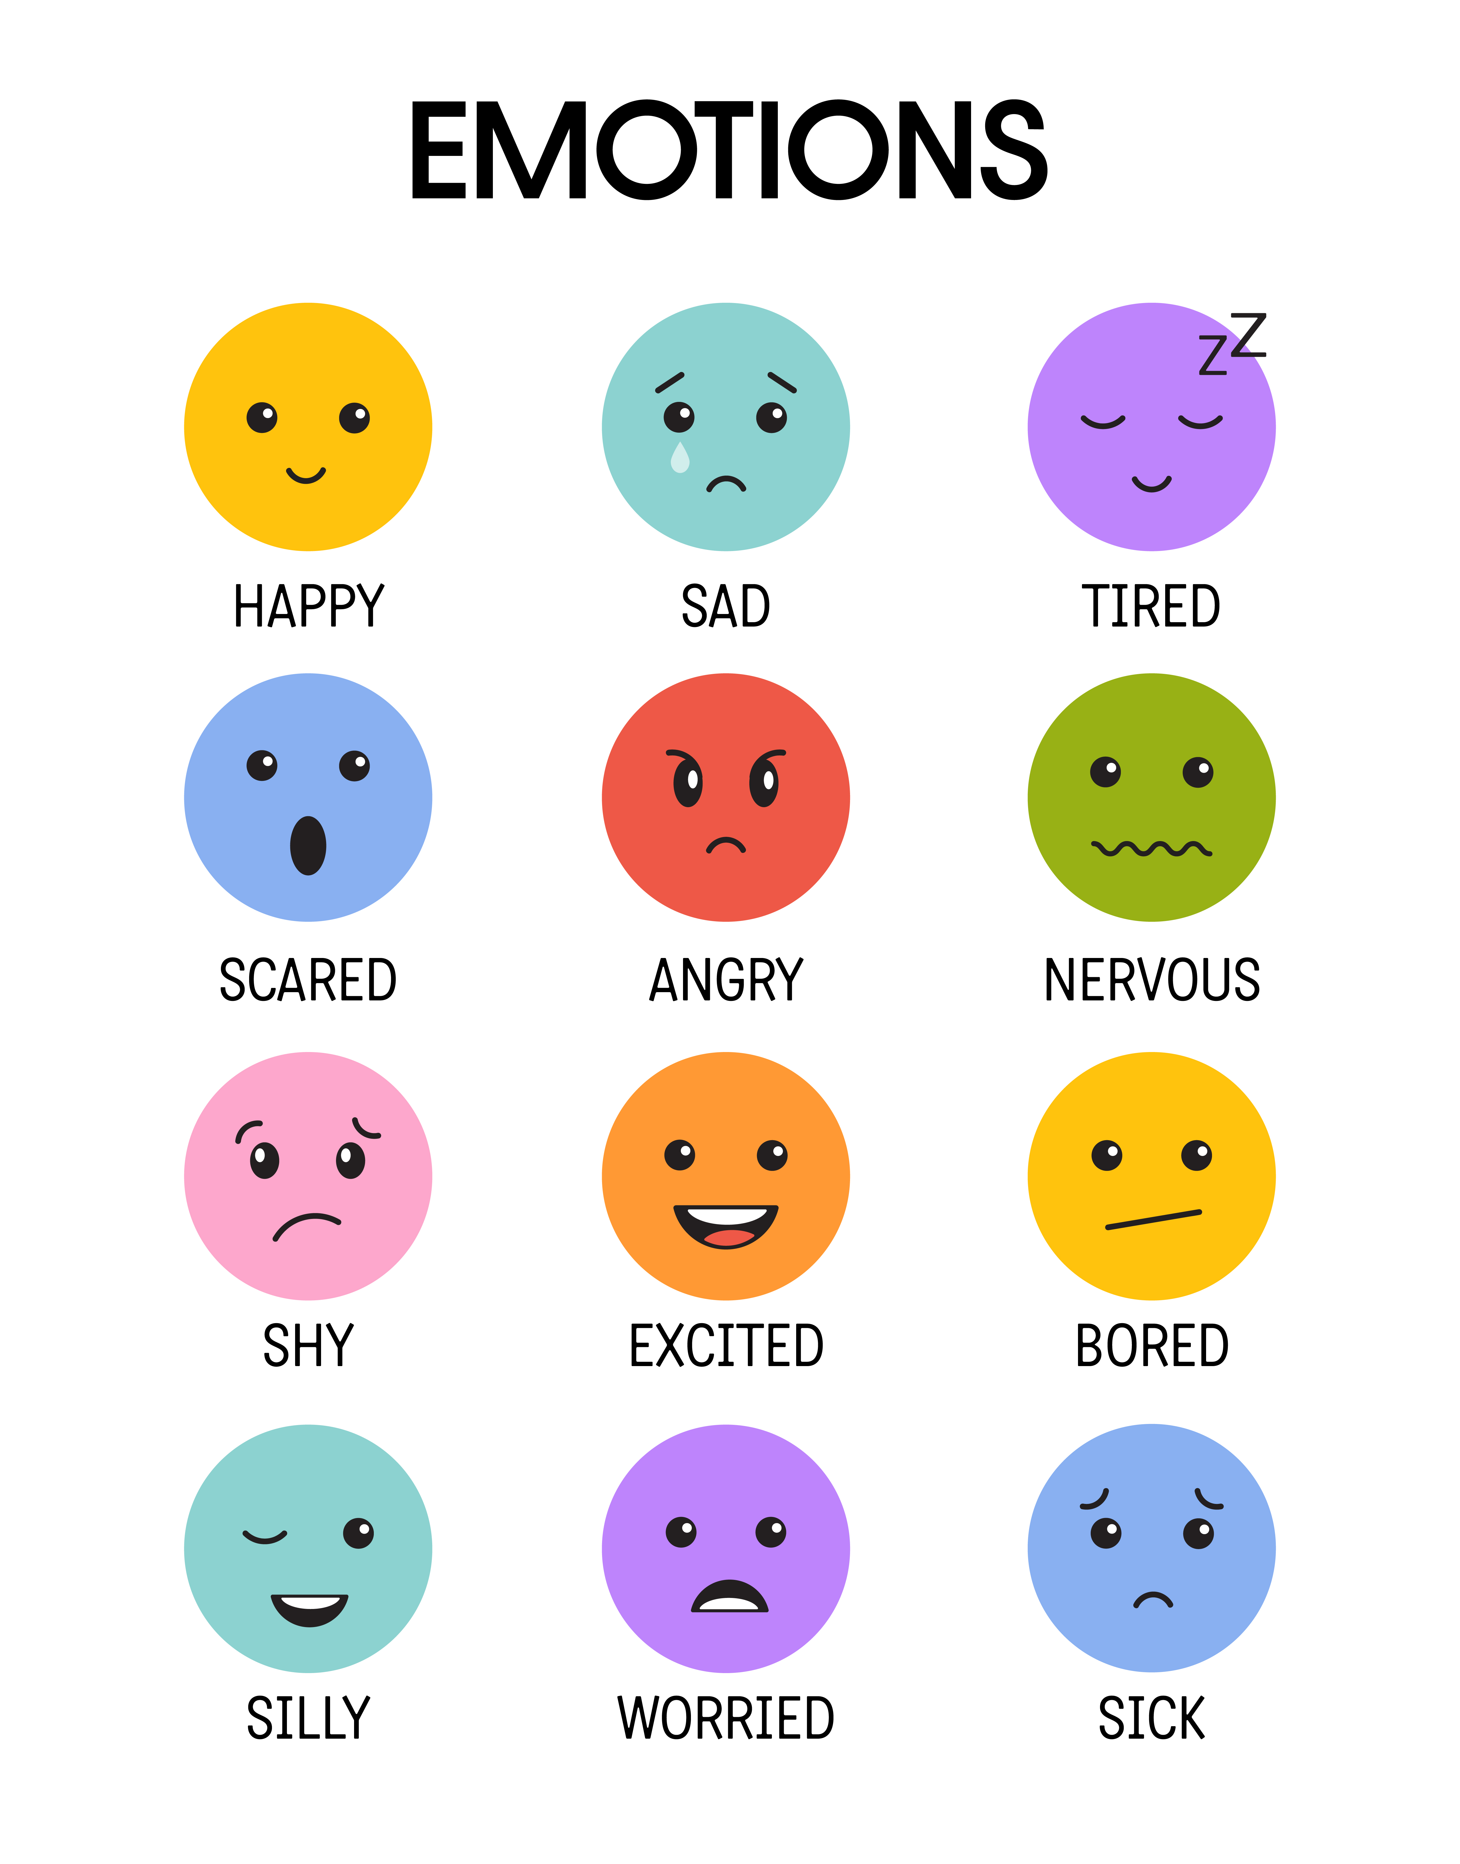
I am feeling (write or draw) …
The feeling is ...
small medium big

What is making me feel this way?
For example, is there something that happened at school that was upsetting? Am I worried about my schoolwork or an upcoming test? Is there something going on outside of school?

What might help me? | If I decide to take a mental health day, how will I spend the day?  - Move my body by:  - Rest and reflect by:  - Get creative by:  - Connect with others by  - Other ideas:
  Examples: Talking to a friend or teacher, making a study plan, doing a fun activity

