ABE/BE

Vocational Education Project in Georgia (VEP)
February 2010 Monthly Report

Submitted by:
American Institutes for Research

U.S. Agency for International Development
Contract No. EDH-I-05-00027-00

VEP FEBRUARY 2010 HIGHLIGHTS

- In response to private sector request for trainees to have more practical training experience, VEP lengthened construction trade courses from one month to three months.
- The newly-designed prototype of the VEP training manual was printed and distributed to MES and private companies for their feedback.
- VEP presented an overview of the Project to Dimitri Shashkini, the Minister of Education and Science;VEP hosted the visit of Roberta Mahoney to Spektri VEC;
- The Spektri Advisory Board Meeting generated positive dialogue among the Project, the MES, and private sector construction companies;
- Kutaisi internal trades’ trainees began a multi-function project in which the three trades will coordinate their activities to renovate a room;
- GBDC, VEP’s subcontractor, began the Labor Market Survey among construction companies;
- Caucasus School of Business presented the employment database designed for use at each VEC;
- 470 trainees are currently enrolled in VEC construction trade courses; 356 in tourism courses.
- VECs have graduated a total of 4,087; 3,635 from the construction courses and 452 from Tourism courses;
- 1,231 graduated construction trades’ trainees have secured employment; 338 graduates of the tourism trades are employed for a total of 1,569 (38%) employed graduates.

INTRODUCTION
USAID’s Vocational Education Project in Georgia is a two-year workforce development project designed to develop and expand vocational education and training to meet labor market demand in the tourism and construction sectors in Georgia.
On May 21, 2008 USAID awarded AIR a contract to implement the Vocational Education Project in Georgia under Contract EDH-I-05-00027-00, Order EDH-I-03-05-00027-00. The original task order had a fixed price of $2,391,995 and was scheduled to run, funding and other factors permitting, until May 20, 2010. A modification to this contract was approved on May 28, 2009, with a new fixed price of $4,096,435, an expansion of work to five vocational training centers and an increase in training numbers from 1000 graduates to 5000 with no change in timeframe.
The Vocational Education Project in Georgia objectives are to:
- Increase the number of tourism and the construction trades graduates trained to international standards from five vocational education centers; and
- Improve the sustainability of the five centers through public-private sector partnerships and established business management/development models.

Technical Approach
The components of VEP’s technical approach to implementing this project, both for the initial start-up phase as well as for the long-term implementation phase, were designed to be mutually reinforcing. Technical assistance to selected VECs emphasizes curricula improvements and professional development that are responsive to known labor market trends, informed by the involvement of key public and private sector stakeholders, and aligned with recognized professional and curriculum standards. Training and pilot programs strengthen the skills of the VEC managers and instructors, raise the status of vocational education programs and graduates, test innovative methodologies, and promote gender equity.

WORKFORCE TRAINING ACTIVITIES
The project collaborates with two centers which specialize in the tourism trades: Tourism Multiprofile College (TMC) “ICARUS” and the Kobuleti Vocational Education and Training Center. VEP cooperates with three VECs which offer construction trade training: the Tbilisi Multiprofile Vocational Center (TMVC) “SPEKTRI,” the Khidistavi Multiprofile Vocational Center and the Kutaisi Multiprofile Vocational Center. These VECs are located in four regions: greater Tbilisi (Icarus and Spektri), Shida-Kartli (Khidistavi), Imereti (Kutaisi) and Adjara/Black Sea coast (Kobuleti).
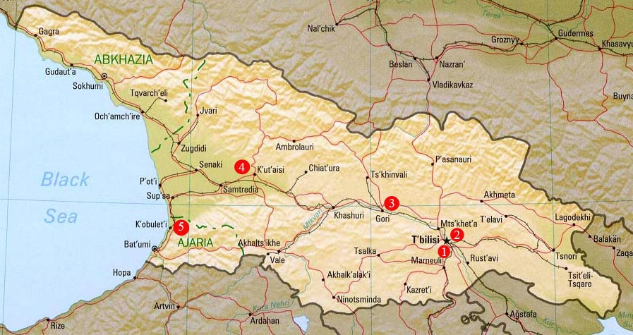
Picture 1: Map of Georgia with Project-targeted Vocational Education Centers Identified.
- Icarus Vocational Center; (2) Spektri Vocational Center; (3) Khidistavi Vocational Center; (4) Kutaisi Vocational Center, and (5) Kobuleti Vocational Center.
In Tbilisi and Kutaisi, anticipated developments in the tourism and construction sectors will create demand for skilled and semi-skilled labor. Both cities also offer strong potential for public-private partnerships. The Khidistavi VEC has been targeted due to its location in a region now heavily populated by recently displaced persons (IDPs) whose needs for new forms of livelihood can be met through VEP’s trainings, followed by placement with anticipated construction projects and light industries that are scheduled for development in the Shida-Kartli region. Close proximity to Tbilisi should provide additional prospects for employment. Courses originally scheduled to be offered at the Polytechnical Vocational Center in Tbilisi were moved to Spektri.
The Icarus Center is training in tourism professions at maximum capacity with great success in employing its graduates, according to its Director. The Kobuleti VEC, near the Black Sea, offers the potential to graduate additional trained professionals in an area frequented by tourists and favored by international hotels.

VEC GRADUATES

Construction Trades

General Developments
In February VEP extended its one-month training courses to three-month duration in response to private sector demand that trainees have more practical experience. Structure of the courses will be:
- Theoretical training (one month)
- Practical training at the VECs (one month)
- On-the-Job Training at a construction site (one month)
The new course structure ensures that trainees will have more real-life construction experience before seeking employment. Eventually, VEP will extend these courses to four months in order to be certified by the Ministry.

    - Spektri VEC

Spektri VEC began a new cycle of classes in February. Of the 211 enrolled trainees, 10 are (5%) are females. The land surveying, road supervision, and soils testing laboratory courses were extended from one month to three-month duration. VEP is collaborating closely with the VEC to extend the additional construction trade courses. However, as a result of the aggressive marketing campaign, 751 students have enrolled for future courses, too many to accommodate in the three-month courses cycle. VEP is working with the VEC to resolve the issue.

ACF International, the humanitarian organization working with IDPs, currently is cooperating with VEP to train IDPs. Ten IDPs from the Samachablo region are enrolled in classes (8 students in plumbing and 2 in electrical wiring). ACF transports these students as they live outside of Tbilisi in the Gardabani region. ACF is committed to finding employment for all IDPs sent for training.

Among the tools and supplies purchased for classes are one laser level for the dry wall class and updated painting tools suggested by representatives from Caparol and Deko. Also, the VEP teacher of the electrical wiring class attended a two-day workshop sponsored by Shrek, an Austrian distributor of electrical supplies.

Several companies such as Architravi, Arci, Mamuli, Magi Style, and Mister Master have expressed interest in employing VEP graduates. Magi Style has visited the Spektri classrooms to observe the skill level of trainees. The company representative shared insights and technical expertise with the VEC instructors.

Recently-published, 1:50,000 scale maps of two areas of Georgia were purchased for the Surveying course, providing much-needed updated information to instructors and trainees. Additional Ordinance Survey maps of Georgia showing the soil patterns can be obtained from the head of the Geodesy and Cartography section. VEP is facilitating the process of obtaining approval from the Minister of the Environment.

2.1.3 Khidistavi VEC
In February Khidistavi VEC extended all of the one month intensive training to three-month courses in response to private sector’s suggestion that one-month trainings did not offer sufficient time to produce a qualified workforce.
The following courses have been extended to three months:
- Tile Setting
- Plumbing
- Electrical
- Painting
- Masonry
- Dry Walling
- Welding
As part of the employment-targeted activities for Khidistavi VEC, VEP in Georgia awarded a micro grant last December to a group of selected graduates who formed and registered a new company - Shida Comforti. Follow up with their company shows that the graduates have successfully completed their first work contract - remodeling a dentistry clinic - in addition to some small remodeling jobs for various people. In February, Shida Comforti hired six more graduates of Khidistavi VEC and expanded its work activities by signing a contract with East Water LLC. The new contract is for equipping several large buildings with the new water meters.

On 25 February, VEP in Georgia, in cooperation with LTD Wood Service, initiated framing and roofing training at the Gori Multifunction Center which is located near a newly-constructed 300-home IDP settlement. Training includes theoretical, practical and on-the-job training components, which will be led by the local and international experts selected by Wood Service. Wood Service management has volunteered to provide transportation for the participants from Tbilisi and also has helped VEP in Georgia identify a professor of the Polytechnic University who will write the framing/roofing training manual which will include chapters on safety, energy-efficiency and environmental considerations.

    - Kutaisi VEC
The last cycle of one-month courses was completed in February at Kutaisi VEC; three-month courses will begin soon.

VEP in Kutaisi is piloting a multi-function project in which three internal trades (Electric, Dry Wall and Painters) work together to refurbish one room. The aim is to construct a Dry Wall system complete with electrical wiring and painting from beginning to the finished stage. Instructors will coordinate the works between trades. This learning simulation provides a real-life construction experience which will allow trainees to understand site coordination among trades and the sequence of implementation.
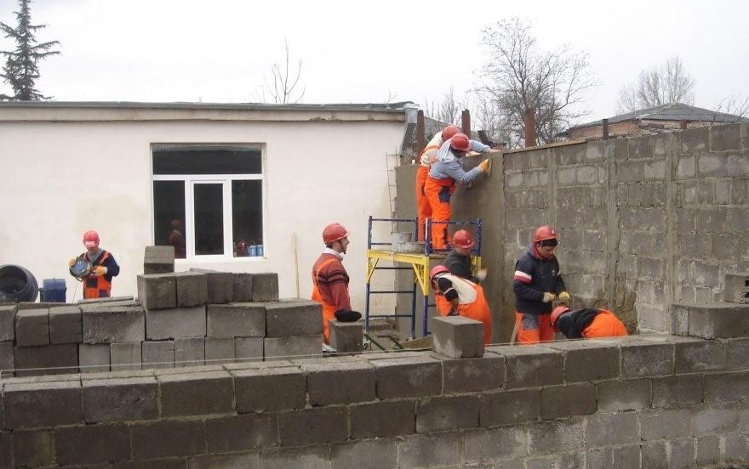
VEP masonry trainees have begun work on a substantial boundary wall required by the VEC. Tinatin Losaberidze, Kutaisi VEC Director, provided permission for VEP students to use this construction as part of their training in masonry application. This allows students to use part of their training time for on-site learning.

GBDC Caucasia, VEP’s subcontractor, sponsored a competition among the Kutaisi VEP graduates who wanted to apply for a small grant offered by VEP. Eleven applications were submitted out of which six applicants were short listed. The applicants prepared their proposals according to the business plan templates provided by the GBDC Caucasia. The following main selection criteria were applied:
  - Past experience
  - Existing networking in construction sector
  - Strategic business vision
  - Number of persons employed
  - Cost realism and cost effectiveness of a proposal
Finally two applicants were selected for award with $2,500 USD for each grant recipient. Awards will be finalized in March.

    - Construction Trade Curriculum Development
The MES previously approved training manuals for the one-month courses in nine construction trades. As VEP shifts to longer courses, the curriculum will be supplemented, in collaboration with the MES and private sector companies, with additional chapters which provide both theoretical foundations and practical simulations. Each new training manual being prepared will contain information including:
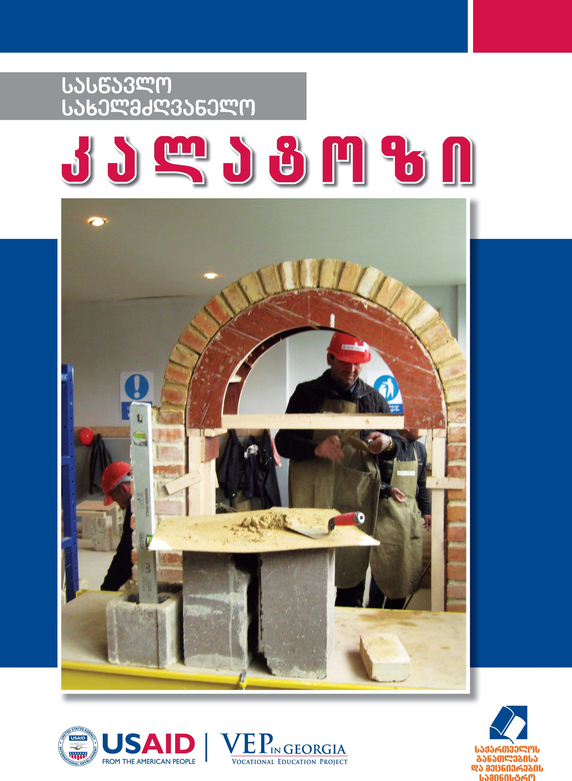
- International safety regulations
- Detailed explanations of the skills required
- Step-by-step visual directions
- Chapter assessments
- Employability Skills
- Entrepreneurial business development guide
- Glossary of technical terms
The training manuals will reflect latest developments in the trades as well as international best practices. The binding of the manuals has changed as well to include heavy, glossy paper, spiral-bound, hard covers to facilitate use by trainees. Manuals will be printed in full color.

The first draft copy of the newly-designed training manual for masonry (which serves as a template for all other trade manuals) was presented to the Minister of Education and USAID Mission Director Jock Conley at a joint meeting on February 21. The initial reception was positive with the Minister providing encouragement to continue development of the construction trade series. VEP pointed out that having an updated curriculum will not only result in better-trained graduates but will also boost private sector confidence in the skills of the VEC graduates.

Following the meeting with the Minister, VEP presented the curriculum to representatives from private sector companies in attendance at the Spektri Advisory Board meeting on February 26. They also enthusiastically supported development of the new curriculum, with some of the representatives volunteering to assist in its development and review before submitting to the MES for approval. Six company representatives took copies of the chapter on safety regulations, already translated into Georgian, to review. MES representatives, also in attendance at the Advisory Board meeting, welcomed the input of the private sector in curriculum development.

Tourism Trades

Icarus VEC
During February several short-term courses continued at Icarus VEC. Courses for 66 waiters and 30 bartenders, which began in January, will end in March. A new course for 15 cooks began in February and will end in April. Until the end of project, VEP will sponsor four more groups (60 trainees) in Icarus: 3 waiters’ courses and 1 bartender course.

Kobuleti VEC
Eight courses which began on 15 January finished on 19 February. On 22 February, five new courses (76 trainees) began training.

Employment numbers for tourism trainees went down in February due to the lack of seasonal employment. The numbers are expected to rise as the tourist season in the coastal resorts begins.

Curriculum for Tourism Courses
Teachers at Icarus completed seven manuals with international tourism expert Niko Kvaratskhelia. These manuals were sent to USAID and MES for approval in December. Due to changes within the Ministry, the approval of the manuals has been delayed. VEC has identified the printer and will send the manuals for immediate publication when approval is obtained. Binding will be the same as described for the construction trade manuals above.

At the 21 February meeting at the Ministry, the MES Vocational Training Director reported that the MES curriculum committee had completed its review of the manuals and would provide VEP its comments soon.

Communications and Outreach
In response to the televised infomercials aired in January, interested applicants continue to call VECs to enroll in courses and private businesses continue to contact VEP about training their employees or employing graduates.
Due to the unexpected enthusiastic response to the televised advertising campaign, additional outreach activities were stopped in Kutaisi and Khidistavi. The advertisements to which VEP had made long-term commitments, i.e., signs on buses, billboards, and an announcement on www.hr.com.ge), still continue.
In the next two months, VEP in Georgia will shift its advertising campaign from attracting students to promoting and enhancing the Vocational Education Centers.

    - Project Brochure
In order to facilitate private sector’s understanding of VEP, project staff prepared an eight-page overview of all VEP activities. The publication, first presented to the Minister and USAID Mission Director, will be distributed at all advisory board meetings and to any company who contacts VEP for project information.
    - Website
With the approval of USAID, VEP updated its website in February. The site can be accessed at www.vep.org.ge.

EMPLOYMENT ACTIVITIES
In February, employment was verified for 233 graduates. To date, 1,231 graduates in the construction trades have secured employment and 338 in the tourism trades. A total of 1,569 VEP graduates are employed. (Details of employment statistics can be found in Appendix B.)

TOURISM TRADE GRADUATES
March 2009 – February 2010

3.1 Job Placement, Career Counseling
In order to facilitate employment of its graduates, VEP in Georgia began implementation of the Direct Contact Campaign in February. The campaign involves identifying companies which are currently hiring and establishing direct contacts with these companies in order to promote VEP’s graduates.
Target companies were identified by the following means:
- VEP in Georgia database;
- Members of business associations (AmCham, ICC Georgia);
- Municipalities’ contractor companies.
Target groups include construction companies as well as developers. Developers were asked to share with VEP in Georgia contact details of their subcontractors.

As a result of the campaign conducted in February, 43 companies have been contacted in Tbilisi and 14 companies were contacted in Kutaisi. As a result of the meetings held, VEP’s Employment Service has identified 24 existing vacancies in Tbilisi and 22 existing vacancies in Kutaisi. Potential vacancies were also identified: 50 in Tbilisi and 30 in Kutaisi. Companies will need to fill these vacancies starting in Spring 2010.

In order to follow the employment status and experience of its graduates, VEP contacts each graduate. However, the Project had not been accurately capturing the number of people who were self-employed. Therefore, VEP initiated a phone campaign in which every person who had been previously listed as “unemployed” was called to determine if they had found employment since the last phone call and /or were self employed. The results of the 1021 phone calls made in February among VEP graduates who stated previously that they were unemployed show that 23% of them had actually found employment that had not been reported. Often the graduates report they are unemployed in hopes the Project will offer them a better job. These figures represent a snapshot of the employment situation and allow VEP to analyze where the greatest employment opportunities are. The statistics in the chart below apply only to the phone calls made in February among the previously reported unemployed and not to the overall employment status of the 4,087 VEP graduates described in “III. Employment Statistics.”

 | Calls made | # of Employed in construction company or related (after courses) | # of Employed in companies in other sector (after courses) | # of Self employed in construction (after courses) | # of Self employed in other sectors (after courses) | Total Employed | Percentage Employed
Tbilisi | 398 | 22 | 26 | 69 | 7 | 124 | 31%
Kutaisi | 193 | 23 | 19 | 25 | 13 | 80 | 41%
Khidistavi | 430 | 2 | 0 | 26 | 1 | 29 | 7%
Summary of month’s calls | 1021 | 47 | 45 | 120 | 21 | 233 | 23%

From the results of the phone calls, it appears that Khidistavi graduates have the most difficulty finding employment. The Shida-Kartli region has a high concentration of IDPs and is predominantly an agricultural area with few ongoing construction projects. VEP will renew its efforts to seek additional employment opportunities for the Khidistavi graduates, even outside the Shida-Kartli region.

The Caucasus School of Business (CSB), VEP’s subcontractor, finalized the creation of the graduates’ database to be installed and maintained by partner VECs. This database is designed to include detailed information about graduates including their academic and professional backgrounds. A shorter version of the database has been designed to be available for potential employers on the VEC’s website. This database will be an internal record into which each VEC can log information about each trainee that will facilitate employment by matching with posted vacancies.

Labor Analysis
VEP modified the subcontract awarded to GBDC to include a labor market survey among 600 businesses in Tbilisi, Kutaisi, Gori, Batumi, and Kobuleti with a focus on construction sector. The questionnaire was developed and agreed with VEP.

In order to test the questionnaire, GBDC introduced it to representatives from the private and public sectors at a meeting at VEP offices. Focus group participants represented the following organizations: Georgian Ministry of Education and Science, Tbilisi City Hall, Georgian Chamber of Commerce and Industry, American Chamber of Commerce, SME Assistance Committee, Higher Professional Education Program at Gori University, ARCI, GL+, Georgian Employers Association, Association of Developers and Builders. (The list of participants is attached in Appendix C.) Following the meeting, the questionnaire was updated based on attendees’ feedback. For example, the Ministry of Education and Science asked to add a question on the employer’s willingness and capacity to pay for his/her employee’s training. The Ministry also submitted a list of vocational professions approved by the relevant Georgian legislation.

The initial list was screened with a focus on the high employment potential of the companies. The breakdown of the survey respondents according to the targeted locations is projected to be:

- Tbilisi – 400
- Kutaisi and Imereti region – 100
- Gori region – 50
- Batumi – 40
- Kobuleti – 10

The survey process, implemented through the Tbilisi, Akhaltsikhe and Batumi offices of GBDC Caucasia, began on February 15, 2010. By the end of the month, more than 60 construction companies in Tbilisi and more than 20 in Kutaisi had been interviewed. Results are sent to VEP as they are collected and entered into the database.

A database specialist, secured by GBDC, created a draft database in Access format to incorporate the survey results and make the relevant analysis. The database has a capacity to generate and print reports according to the companies and vocations in need. Once the survey results are entered into the database, it will become possible to obtain significant statistical data.

Final results of the Labor Market Survey will be available in April.

- STAKEHOLDER ENGAGEMENT

4.1 Meeting with the Minister of Education and Sciences
VEP’s COP and DCOP met with Dimitri Shashkini, the Minister of Education and Science on 21 February. USAID Mission Director Jock Conly, USAID’s Director of Health and Social Development Anne Patterson and VEP’s COTR Medea Kakachia were also in attendance. VEP presented an overview of the project’s accomplishments and planned future activities. Included in the presentation was a sample of the curriculum format VEP is proposing which the Minister received enthusiastically. The Minister expressed his appreciation of Project efforts and requested continued close collaboration with Ministry counterparts.

4.2 USAID’s Regional Director’s Visit to Spektri VEC
VEP hosted a brief visit to Spektri VEC by Roberta Mahoney, USAID’s Assistant Administrator along with other US State Department and USAID officials. The delegation toured classrooms to observe trainings in process and had the opportunity to look at the new curriculum format.

4.3 Advisory Board Meetings
On Friday, February 26, VEP hosted the Spektri Advisory Board Meeting at the Sheraton Hotel in Tbilisi. Attendance at the meeting exceeded expectations with 14 representatives from 11 private sector companies, two Ministry personnel and 3 Spektri management staff attending. Saba Sarishvili, VEP’s Employment Director, chaired the meeting.

The meeting demonstrated the increased interest of the public sector in the training efforts of the VECs. The public sector companies’ expressed need to employ trained trades people was indicative of the emerging growth within the Georgian construction industry.

Two topics sparked lively discussion among the attendees: the training efforts, specifically the curriculum, and the upcoming job fair. The attendees welcomed the development of new curriculum, volunteering to assist in the development and review of all materials. Several companies took copies of the safety chapter, already translated into Georgian, to give to their Safety Managers for review. The discussion quickly turned to the development of industry standards. VEP offered to facilitate a meeting between the construction companies and the MES to discuss the standards that the MES is currently developing. The MES expressed its appreciation for both public sector involvement and VEP’s offer to host the meeting.

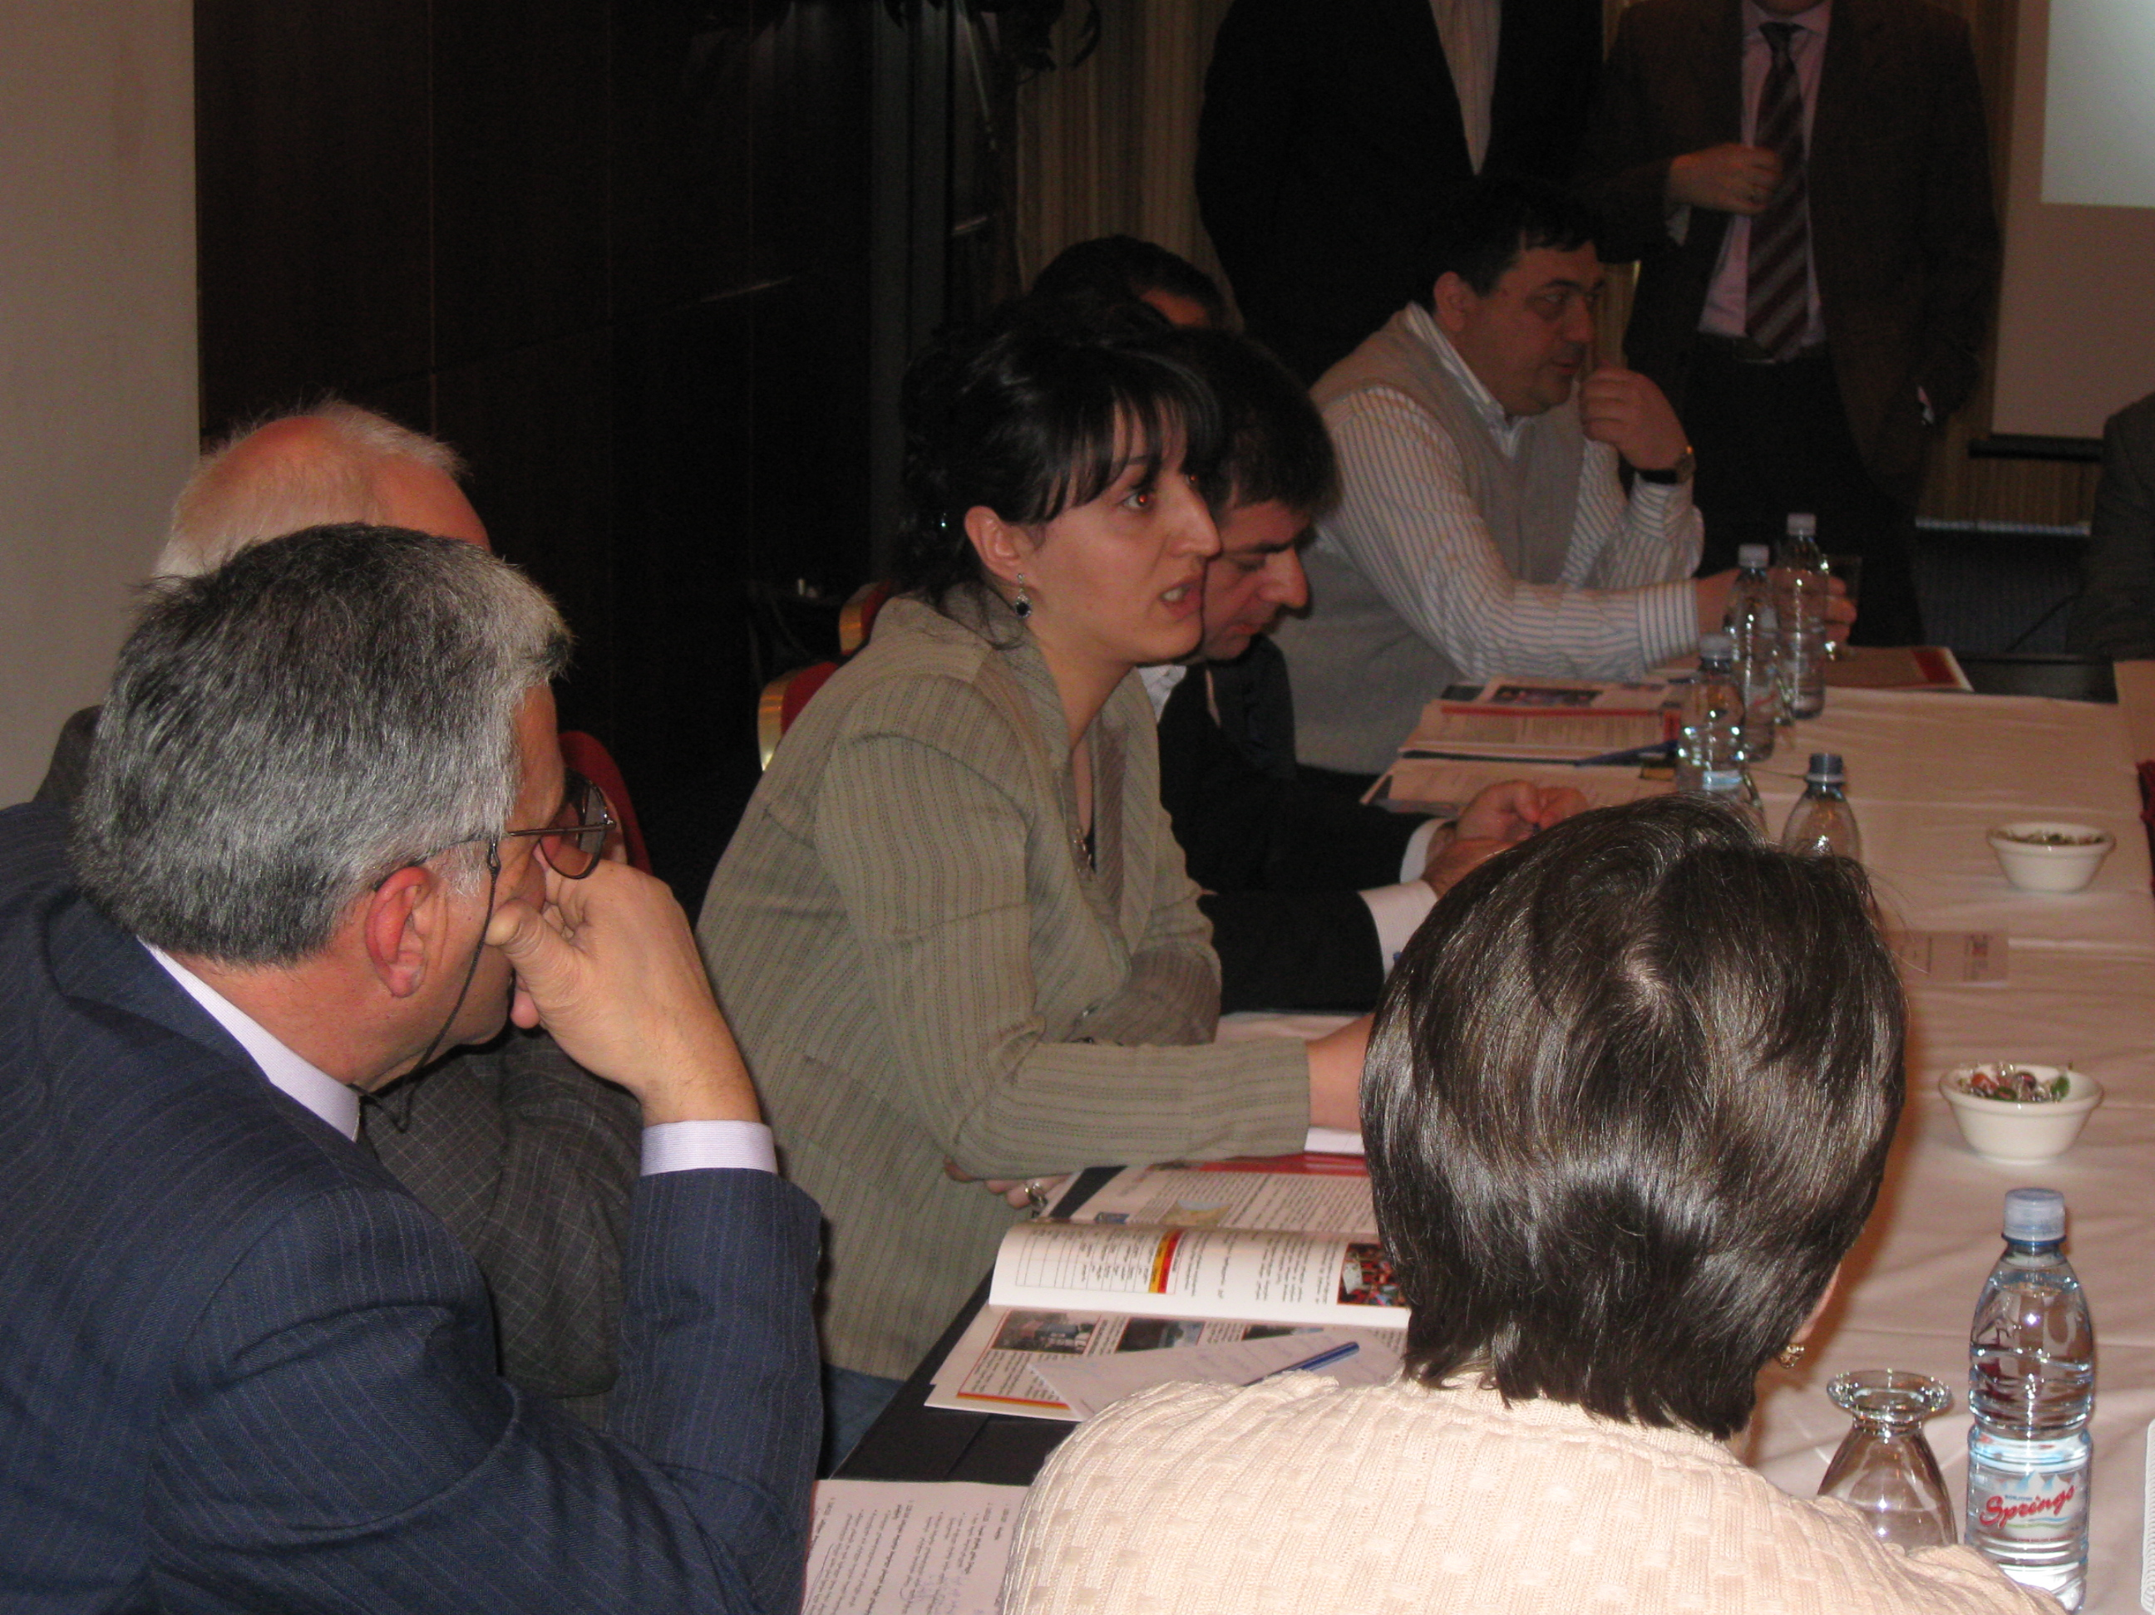
Brainstorming for the upcoming job fair, planned for April 2010, produced enthusiastic responses from the companies. One idea led to another until the companies agreed that the best venue for the fair would be a room at the Spektri VEC which had been renovated by VEP trainees using materials supplied by the companies. A smaller committee of company representatives will form the committee to plan the fair.

This Advisory Board Meeting marked the first time private sector companies expressed a responsibility and determination to ensure the success of the VECs. They were keen to assist in the development of curriculum, industry standards and the job fair. VEP will follow up all offers from representatives of the companies in order to capitalize on private sector input and will continue to host regular meetings to build on the momentum established at this meeting. An Advisory Board Meeting in Kutaisi is scheduled for early March.

V. PROJECT CHALLENGES AND OPPORTUNITIES
VEP sees only opportunities for the Projects and no significant challenges. As reported each month, the construction sector continues to suffer significant delays but there are hopeful signs that the market is beginning to open. As VEP monitors developments in the market, more employment vacancies are identified. Slowly but steadily the employment statistics are improving.
VEP has also entered a new phase in its relationships with private sector companies which have expressed a commitment to provide assistance to the VECs. VEP has identified avenues of cooperation between the companies and the MES which the project will continue to promote.
VEP has the tremendous opportunity to provide quality training manuals to the VECs, written in cooperation with the MES and private sector companies. This competency-based curricular series will ensure trainees are trained in best practices and will build the confidence of prospective employers in VEC graduates.
Lengthening the construction-trade courses to three-month duration increases the trainees’ exposure to construction best practices and boosts the probability of employment. Eventually, VEP hope its courses will merge completely with the MES’s courses.
VEP is capitalizing on the momentum established through the effective marketing campaign, private sector increased involvement and the interest generated in the new curriculum to achieve its deliverables in the remaining months of this phase of the project. The project anticipates all that can be accomplished if an extension is granted.

PLANNED ACTIVITIES FOR MARCH 2010
- Tourism curriculum will be published upon receipt of MES approval.
- Advisory Board Meeting in Kutaisi on March 9.
- Collaboration with MES on curriculum development.
- Employing Employment Services and PPP officers in Spektri and Khidistavi.

Vocational Education Project in Georgia
Contact Information:
Organization:  Address:  Phone:  COP:  Home Office:  Telephone:  Web site: | American Institutes for Research (AIR)  Abashidze St. 42, Apt. #28, Tbilisi, Georgia  (+995 32) 25-15-36; 22-06-44  Nancy Parks (nparks@air.org)  1000 Thomas Jefferson Street, N.W.,  Washington, D.C. 20007-3835  (202) 403-5000 / TDY 1-877-334-3499  (202) 403-5454  www.air.org

APPENDIX A: FEBRUARY 2010 TRAINING STATISTICS
Spektri VEC | Graduated | In Training | Enrolled next month | Start-Up Date
Masonry | 103 | 21 | 31 | March 15th
Tile-Setting | 307 | 24 | 190 | March 15th
Electric | 294 | 28 | 190 | March 15th
Plumbing | 254 | 23 | 86 | March 15th
Knauf Dry Wall | 91 | 25 | 83 | March 15th
Land Surveying | 72 | 23 | 35 | April 15th
Painting | 80 | 21 | 82 | March 15th
Soil and Concrete Lab | 54 | 7 | 2 | April 15th
Roads Supervisory | 71 | 18 | 20 | April 15th
Steel Fixing | 50 | 21 | 32 | March 15th
Interveldi, Tbilisi | 283 | 40 | N/A
TOTAL | 1,659 | 251 | 808
Khidistavi VEC | Graduated | In Training | Enrolled next month | Start-Up Date
Tile-Setting | 314 | 18 | 55 | April 15th
Electric | 132 | 12 | 13 | April 15th
Plumbing | 240 | 14 | 28 | April 15th
Painting | 85 | 16 | 28 | April 15th
Masonry | 21 | 13 | N/A | April 15th
Knauf Dry Wall | 98 | 15 | 21 | April 15th
Welding | N/A | N/A | 65
TOTAL | 890 | 88 | 210
Kutaisi VEC | Graduated | In Training | Enrolled next month | Start-Up Date
Paving / Cobble Stone | 156 | 12 | 0
Electric | 245 | 20 | 0
Masonry | 94 | 19 | 0
Knauf Dry Wall | 178 | 22 | 0
Painting | 153 | 18 | 0
Welders’ Institute, Kutaisi | 260 | 40 | 57 | March 30th
TOTAL | 1086 | 131 | 57
Icarus VEC
Full year courses | 69 | 187 | 41 | April 6th
Short term Waiter | 28 | 46 | 66 | March 15th
Short term Bartending | 23 | 30 | 58 | March 15th
Short-term Cook | 0 | 17 | 61
Total | 120 | 280 | 226
Kobuleti VEC | Graduated | In Training | Enrolled Next Month
Waiter | 74 | 15 | 23
Bartender | 43 | 15 | 37
Cook | 60 | 15 | 58
Confectioner | 62 | 16 | 74
Hotel reception | 49 | 15 | 39
Guide | 31 | 0 | 17
Housekeeper | 13 | 0 | 11
Total | 332 | 76 | 259
Grand TOTAL | 4087 | 826 | 1503

APPENDIX B: EMPLOYMENT STATISTICS

233 Trainees obtained employment in January. Total of construction trade graduates employed: 1231.

Companies which have employed 47 VEP graduates in the construction trades in February, 2010:

- LTD “Ebrisi” – 1;
- LTD “Axis” – 4;
- Auto service center – 1;
- LTD “Baghdatelebi” – 1;
- Road Department – 1;
- Expo Georgia – 1;
- LTD “Arci” – 1;
- RadissonBlu Iveria Hotel – 1;
- LTD “Kako” – 1;
- Energo-Pro Georgia – 3;
- Old Tbilisi Project -1;
- Transmsheni – 1;
- Renovation of Central Library – 1;
- Media Printing House – 1;
- House Art -1;
- LTD “Iberia 21” – 2;
- GS -1;
- Big Georgia -2;
- LTD “Meokhi” -1;
- Railway Reconstruction – 1;
- Ortachala Market Reconstruction – 1;
- Partnership “Sami” – 1;
- LTD “Burji” -1;
- LTD “Bermukha” – 1;
- Vertical Lift Service -1;
- Tsavkisi Valley – 1;
- Eco-Georgia -1;
- DS -1;
- VIP Georgia -3;
- Kapa+ - 1;
- Senaki Building Company -1;
- Khoni Building Company -1;
- Prison Building -1;
- LTD DR -1;

Self-employed: 120

- Electrical works-25
- Welding works-15;
- Reconstruction works -27;
- Tile-setting -23;
- Plumbing works -15;
- Painting works – 6;
- Knauf -5;
- Cobble-stone specialist -4;

Employed in other field: 66

- United Telecom -1;
- Computer equipments shop -1;
- Bellboy in Cruise-1;
- GPC Pharmacy -1;
- Goodwill -1;
- Research Institute-1;
- Medi-Club Georgia-1;
- Security Service-3;
- PTP Export Company-1;
- LTD “Alta” -1;
- NGO “Youth Forum”-1;
- Police-1;
- School Teacher-1;
- Sport News Operator -1;
- Distributor-1;
- Imedi TV-1;
- LTD “Antre” -1;
- LTD “A-rating”-1;
- Restaurant White House-1;
- Distributor -2;
- Managed System Institute-1;
- Bakery-1;
- Financial Organization -1;
- Computer Service-1;
- Trainer of Judo-1;
- IT-1;
- Driver-1;
- Private Small Business-2;
- Football Trainer-1;
- Store House-1;
- Furniture Workshop -1;
- Web Designer-1;
- Gold Market-1;
- Trader -1;

APPENDIX C: Labor Market Survey Focus Group Participants

- Ministry of Education and science, Nani Dalakishvili
- Georgian Chamber of Commerce and Industry – Tamta Mikaberidze, Giorgi Epitashvili
- AmCham – Keti Sidamonidze
- SME support committee - Kakha Kokhreidze
- Georgian Technical University - Lali Ghogeliani
- Development Company ARCI – Temur Megreladze
- developers Association - Irakli Rostomashvili
- Georgian Employers Association – Mikheil Kordzakhia
- Company GL+ - Nata Memanishvili
- Tbilisi City Hall – Iuza Tsotseria

APPENDIX D: Tourism/Construction Sector Updates

Sighnaghi Tourism Seminar
A three-day seminar “Tourism in Georgia” was held in Sighnaghi and jointly sponsored by theTourism and Resorts’ Department of the Ministry of Economy, as well as Adjara Tourism and Resorts’ Department and the Tour Operators’ Association. The following issues were discussed at the seminar: current challenges; priorities and new tourist products; tourism training courses; partnerships among state, private and non-governmental sectors. The representatives of Tbilisi City Hall, the Ministry of Education, the Agency of Protected Areas and the Tour Operators’ Association were among the attendees.

Georgian Companies Bidding on Ukrainian Tenders
Georgian companies that work on road infrastructure development will be able to apply for tenders from Ukraine that are announced in Georgia, according to a memorandum signed in Ukraine by Rmaz Nikolaishvili, the Head of Roads’ Department of Georgia, and Genadi Savchenko, the Head of Highway Service of Donetsk district. Genadi Savchenko.

Renovated Agmashenebeli Avenue
One of Tbilisi’s oldest and the most beautiful streets – David Agmashenebeli Avenue – will be soon renovated. Tbilisi City hall has already started the rehabilitation works. The project considers reconstruction works from Tamar Mepe Avenue to Saarbrucken Square. The first stage of the project will restore about 70 buildings. At present 30 building are under reconstruction. The entrance doors will be restored or changed, the footpaths will be paved and natural gas pipes and electrical and telephone wires will be placed under the ground.

Kalaubami Project
Tbilisi City Hall is initiating the reconstruction/rehabilitation of one of the oldest parts of Tbilisi – Kalaubani. The area still holds churches dating from the Middle Ages and houses from the 1800’s. The rehabilitation works started in February, 2010. About 30 dwelling houses will be rehabilitated. The roofs of old buildings will be replaced and the yards will be surrounded by brick walls. Sewage and water pipes will be changed. The project is sponsored by Tbilisi City Hall.

Tourism Multiprofile College (TMC) “ICARUS”, the Tbilisi Multiprofile Vocational Center (TMVC) “SPEKTRI , the Polytechnical Vocational Training College in Tbilisi, the Khidistavi Multiprofile Vocational Center, and the Kutaisi Multiprofile Vocational Center.

